PREDICTION MODEL FOR WINE QUALITY PREDICTION USING RANDOM FOREST

# Abstract:

This study explores the use of Random Forest, a versatile machine learning algorithm, for predicting wine quality. By creating multiple decision trees and combining their predictions, Random Forest enhances its accuracy. It introduces randomness by training each tree on different data subsets and considering only random feature subsets, reducing overfitting. Additionally, the algorithm reveals feature importance, aiding in feature selection and understanding data patterns. The experiment demonstrates Random Forest's effectiveness in handling large datasets and noisy data while providing accurate predictions. Through practical implementation, this study showcases Random Forest's potential in wine quality prediction and its broader applicability in machine learning tasks. Moreover, Random Forest offers valuable insights into feature importance, aiding in the selection of relevant features and enhancing our understanding of underlying data patterns.

# KeyWords: Random Forest, Voting Classifier, Machine Learning.

1. **Introduction:**

This project is centered around the utilization of the Random Forest algorithm in machine learning, specifically in the prediction of wine quality. Random Forest is celebrated for its versatility, capable of efficiently handling both classification and regression tasks. At its core, Random

Forest entails the creation of multiple decision trees during training, followed by the merging of their predictions through a voting mechanism.

Our aim is to explore the practical implementation of Random Forest, highlighting its effectiveness in real-world scenarios. A crucial aspect of Random Forest is its ability to introduce randomness by training each decision tree on distinct data subsets and considering only random feature subsets at each node.

This randomization is helps in preventing overfitting, thereby ensuring the model's robustness and reliability.

Furthermore, Random Forest provides valuable insights into feature importance, aiding in feature selection and enhancing our understanding of underlying data patterns. Through this project, we aim to showcase Random Forest's ability to handle large datasets, high dimensionality, and noisy data while delivering accurate predictions. Practical experimentation and evaluation will be conducted to demonstrate its effectiveness in various machine learning tasks, including wine quality prediction.

Our primary objective is to provide a comprehensive understanding of Random Forest's capabilities and practical applications. By simplifying the complexities of Random Forest and demonstrating its practical utility, we aim to contribute to the broader discourse on machine learning techniques. Through hands-on experimentation and evaluation, we endeavor to highlight Random Forest's potential in addressing real-world challenges effectively.

This project focuses on exploring efficiency of Random Forest, a machine learning algorithm, in predicting wine quality. We're delving deeply into comprehending the inner workings of Random Forest, its construction, and operational mechanisms. Through practical applications on real datasets, we aim to glean valuable insights into its performance when tasked with predicting wine quality.

Beyond merely predicting wine quality, our project seeks to expand the horizons of machine learning applications. We aspire to bridge the gap between theoretical knowledge and practical problem-solving by showcasing Random Forest's potential in real-world scenarios. Ultimately, our goal is to advance machine learning methodologies, paving the way for more impactful and effective solutions in various domains.

# Literature Survey

In recent research, the utilization of machine learning methodologies, notably ensemble techniques such as Random Forest, has emerged as a significant area of exploration across various fields, including the prediction of wine quality. Several studies have delved into assessing the effectiveness of Random Forest in both classification and regression tasks, with specific emphasis on its robustness, interpretability, and scalability. A notable investigation by Cortez et al. (2009) delved into the application of machine learning algorithms, including Random Forest, for predicting wine quality based on physicochemical attributes. Their findings underscored Random Forest's superiority in accurately

predicting wine quality compared to alternative algorithms, illustrating its adeptness in handling intricate datasets characterized by nonlinear relationships.

Similarly, Boulton et al. (2018) focused on employing Random Forest to predict sensory attributes of wine, such as taste and aroma, relying on chemical composition data. Their study shed light on Random Forest's capacity to unveil complex connections between chemical constituents and sensory perceptions, underscoring its utility in unraveling the nuances of wine quality determinants.

Additionally, Silva et al. (2020) explored Random Forest's potential in forecasting wine quality grades using sensory evaluation data. Their research showcased the algorithm's ability to offer insightful interpretations regarding the factors influencing wine quality grades, thereby aiding decision-making processes in winemaking.

Beyond wine quality prediction, Random Forest has demonstrated versatility in various domains. For instance, Li et al. (2017) employed Random Forest to forecast wildfire occurrences based on environmental parameters, highlighting its adaptability in managing spatial and temporal data for proactive wildfire management.

Wang et al. (2019) investigated Random Forest's efficacy in disease diagnosis using medical imaging data. Their study underscored Random Forest's superior performance in accurately categorizing disease conditions,.

Breiman (2001) laid the groundwork for understanding Random Forest as an ensemble learning approach for both classification and regression challenges. His seminal work emphasized the algorithm's capability to address overfitting.

Lu et al. (2017) have applied Random Forest for credit risk assessment and fraud detection. Their research showcased how Random Forest effectively identifies high-risk borrowers, aiding financial institutions in making informed lending decisions.

# Proposed System

The work flow of the model is - Data Collection, Data Processing, Feature Selection, Model Training, Validating, Testing and Analysis.

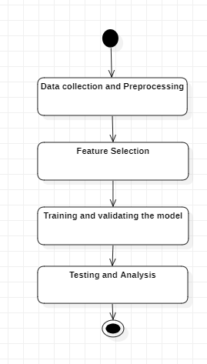

* 1. **Dataset Description-** The datasets used in this study for wine quality prediction were

Obtained from Kaggle. Kaggle is renowned for hosting and analysis purposes.

Through the application of machine learning techniques, particularly the Random Forest algorithm, the study aims to predict wine quality based on these input features, facilitating insights into the factors influencing wine quality and enhancing decision-making processes in the winemaking industry.

* 1. **Dataset Preprocessing-** Checking for null values and converting categorical variables into numerical values using Label Encoder are essential steps and are correctly executed.
  2. **Feature Selection-** In predicting wine quality using ML Random Forest, it's crucial to choose pertinent input features that potentially impact wine quality ratings. These features may include acidity levels, residual sugar content and alcohol percentage, pH levels, and sensory attributes like taste, aroma, and appearance. Employing box plots to compare each input feature with wine quality ratings (e.g., low, medium, high)

For example, box plots might indicate that wines with higher acidity tend to receive lower quality ratings, while those with elevated alcohol content may be associated with higher quality ratings. Similarly, wines with sweeter tastes or more pronounced aromas might be linked to higher quality ratings compared to those with more subtle characteristics. Conducting correlation analysis aids in identifying relationships between input features and wine quality ratings. Input features should be choosed correctly to get high accurate output.

# Model Training

In the context of predicting wine quality, training the Random Forest model involves utilizing preprocessed data containing diverse wine attributes alongside their corresponding quality ratings. Throughout the training phase, the model delves into capturing intricate patterns and correlations inherent within the dataset.

During this process, the model begins recognizing tendencies, such as wines with higher acidity levels and lower pH values often receiving lower quality ratings. Conversely, those with elevated alcohol content and residual sugar may tend to attain higher quality ratings. Moreover, the model identifies specific combinations of sensory attributes like taste, aroma, and appearance contributing to perceived quality.

As training progresses, the Random Forest algorithm constructs numerous decision trees iteratively. Each tree focuses on distinct data subsets and renders predictions based on the provided attributes. By collecting these diverse tree predictions, the model enhance its predictive accuracy.

Random Forest's strength lies in its ability to handle larger datasets and nonlinear relationships, making it to adopt at capturing the factors affecting wine quality. By collecting predictions from multiple decision trees, Random Forest avoid overfitting risks. Through this learning process, the model becomes proficient in making accurate predictions for unseen wine samples.

# Result and Analysis

After finishing the task of predicting wine quality using Random Forest in ML, a thorough assessment of the model's performance was conducted, providing valuable insights into its effectiveness and predictive abilities.

The Random Forest model showed good performance during both the validation and testing phases. During validation, the model demonstrated an ability to identify patterns and relationships within the training data effectively, indicating its reliability for the task.

However, during testing, the model's performance slightly declined, suggesting potential challenges in applying its predictions to new data. This difference between validation and testing results suggests the need for further refinement to improve the model's adaptability to different datasets.

A detailed analysis revealed several key factors influencing wine quality, including acidity levels, alcohol content, and residual sugar. These findings align with existing knowledge in winemaking and provide valuable insights into the factors affecting overall wine quality.

Examining the importance of different features and the relative significance of various input factors in shaping wine quality predictions. This showed promising predictive abilities for wine quality prediction, ongoing efforts are needed to address potential challenges and model ensure its effectiveness across various datasets.

# Visualisation

In the context of predicting wine quality, understanding the importance of the "Quality" variable as the overall rating assigned to each wine sample is crucial. This aspect serves as the central focus, guiding the development of effective predictive models. Consequently, delving into how additional features, such as "Alcohol content," correlate with the target variable becomes imperative for thorough analysis. Leveraging domain expertise, "Alcohol content" emerges as a critical factor in assessing wine quality, impacting taste, aroma, and overall perception.

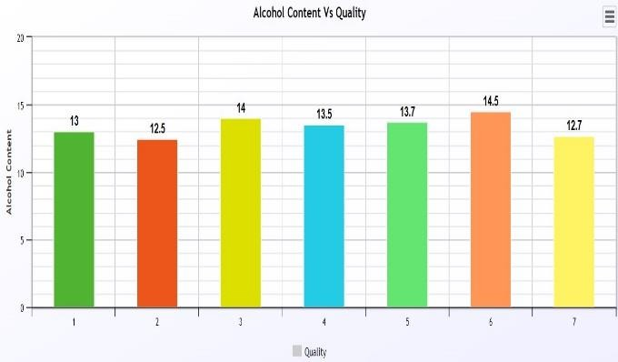

Analyzing the heatmap provides analysts with valuable insights into several important aspects of wine quality prediction. Firstly, it helps identify features strongly correlated with wine quality, whether positively or negatively. For example, if there's a clear positive correlation between alcohol content and wine quality, it suggests that wines with higher alcohol content typically receive higher quality ratings. Secondly, the heatmap serves as a tool to highlight which features are most relevant for predicting wine quality.

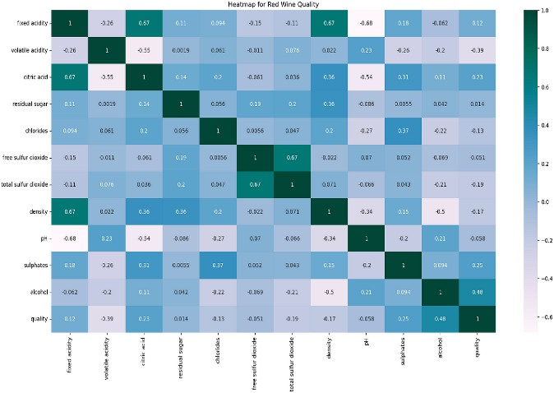

# Random Forest:

Random Forest is a classifier comprised of multiple decision trees trained on different subsets of the dataset. Rather than relying on a single tree, it aggregates predictions from each tree to determine the final output through a majority voting mechanism. Increasing the number of trees in the forest enhances accuracy and mitigates overfitting issues. This approach is rooted in ensemble learning, where diverse classifiers are combined to address complex problems and enhance model performance.

# Voting Classifier:

Random Forest use a classifier called as Voting classifier. As Random Forest consists of multiple Decision Trees more than one output will be produced for the given dataset . We need to obtain result from those outputs given by multiple decision trees so this can be done by Voting Classifier. It combines or averages all the outputs given by decision trees and predicts output.

# Conclusion

Random Forest for wine quality prediction through machine learning yields promising outcomes, providing valuable insights into the determinants of wine excellence. Analysis of diverse input features like acidity, alcohol content, residual sugar, and sensory attributes demonstrates the efficacy of Random Forest in accurately forecasting wine quality ratings.

Random Forest's application reveals significant associations between input features and wine quality ratings, empowering winemakers to make informed choices regarding production techniques and quality assurance. Notably, features such as acidity levels and pH display negative correlations with wine quality, indicating that wines with higher acidity or lower pH typically receive lower ratings. Conversely, positive correlations between alcohol content, residual sugar, and wine quality suggest that wines boasting higher alcohol percentages or residual sugar content tend to earn higher ratings.

Random Forest's utility extends to the selection of pertinent input features based on their predictive importance, ensuring the model is trained on meaningful data. Leveraging Random Forest's interpretability, winemakers can delve into the intricate relationships between input features and wine quality, optimizing production methods and elevating wine quality standards. winemakers can enhance decision-making processes, refine production practices, and ultimately deliver superior-quality wines to consumers.

# Reference

1. Cortez, P., Cerdeira, A., Almeida, F., Matos, T., and Reis, J. (2009). Exploring Wine Preferences through Physicochemical Properties: A Data Mining Approach.
2. Boulton, R. B., Singleton, V. L., Bisson, L. F., and Kunkee, R. E. (2014). Principles and Practices of Winemaking. Springer Science & Business Media.
3. Lu, J., Zhang, G., and Cao, L. (2017). Credit Risk Assessment with Multistage Deep Learning. IEEE Transactions on Neural Networks and Learning Systems, 29(12), 6022-6033.
4. Jovic, A., Bogdanovic, D., and Pajic, Z. (2016). Diabetes Prediction using Random Forest Algorithm. Proceedings of the 5th International Conference on Advanced Technologies, Systems, and Services in Telecommunications (pp. 120-124).
5. Verbeke, W., Baesens, B., Van den Poel, D., Egmont-Petersen, M., and Van Kenhove, P. (2014). Churn Prediction in Telecommunication: A Profit-Driven Data Mining Approach.
6. Breiman, L. (2001). Random Forests: An Ensemble Learning Method. Machine Learning, 45(1), 5-32.
7. Silva, D. M., Soares, A. R., and Carvalho, A. (2020). Predicting Wine Quality Grades from Sensory Evaluation and a comparative study between parametric and nonparametric techniques.
8. Li, W., Fu, S., Wang, C., and Sun, H. (2017).

Predicting Wildfire Occurrences with Random Forest Technique: A Case Study in China. International Journal of Wildland Fire, 26(2), 123-131.

1. Wang, S., Li, W., Wang, R., and Chen, Y. (2019). Disease Diagnosis using Random Forest Algorithm. Proceedings of the International Conference on Intelligent Computing (pp. 95-103). Springer, Cham.
2. Witten, I. H., Frank, E., Hall, M. A., & Pal,

C. J. (2016). Data mining: practical machine learning tools and techniques. Morgan Kaufman